# Chapter 1

Objectives in this chapter:

■■ Objective 1.1: Create the document structure

■■ Objective 1.2: Write code that interacts with UI controls

■■ Objective 1.3: Apply styling to HTML elements programmatically

■■ Objective 1.4: Implement HTML5 APIs

■■ Objective 1.5: Establish the scope of objects and variables

■■ Objective 1.6: Create and implement objects and methods

Obejective 1.1: Create the document structure

This objective covers how to:

■■ Use HTML5 semantic markup

■■ Create a layout container in HTML

■■ Optimize for search engines

■■ Optimize for screen readers

**Use HTML5 semantic mark-up**

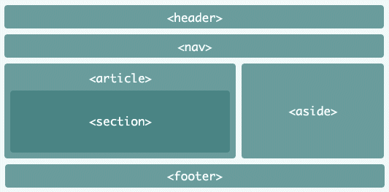

Html5 traz uma nova forma de estruturar o código de forma semântica, para que isso faça sentido para o navegar e para o SEO que está buscando por sites relevantes. Algumas desses tags de marcação semânticas adicionadas pelo html5 são: <header>, <nav>, <article>, <section>, <aside> e <footer>.